**<PROJECT TITLE>**

**A MAJOR PROJECT**

**REVIEW-3 REPORT**

**SUBMITTED BY,**

**BATCH –**

**STUDENT-1 NAME STUDENT-2 NAME**

**(ROLL NUMBER) (ROLL NUMBER)**

**STUDENT-3 NAME STUDENT-4 NAME**

**(ROLL NUMBER) (ROLL NUMBER)**

**Project Supervisor**

**Dr. P. Rama Santosh Naidu**

**Senior Assistant Professor**



**DEPARTMENT OF COMPUTER SCIENCE AND ENGINEERING**

**MVGR COLLEGE OF ENGINEERING (AUTONOMOUS)**

**VIZIANAGARAM-535005, AP (INDIA)**

**(Accredited by NBA, NAAC, and Permanently Affiliated to**

**Jawaharlal Nehru Technological University Kakinada)**

**TABLE OF CONTENTS**

|  |  |  |
| --- | --- | --- |
| **S.No** | **Contents** | **Page No** |
| **1** | **ABSTRACT** |  |
| **2** | **INTRODUCTION** |  |
| **3** | **REQUIREMENTS** |  |
| **4** | **DESIGN & ANALYSIS** |  |
| **5** | **IMPLEMENTATION** |  |
| **6** | **TESTING** |  |
| **7** | **CONCLUSION & FUTURE WORK** |  |
| **8** | **REFERENCES** |  |

**ABSTRACT**

We propose a specialized software solution to enhance educational institutions'

performance analysis by digitizing and analysing student marks obtained from

scanned mark sheets.

This system leverages Python's CV2 module for mark segmentation and utilizes

customizable YOLOv7 object detection for accurate digit recognition, addressing issues like image inconsistencies and unclear borders.

The stored digital data allows for historical analysis and actionable insights into

student performance, aligned with Bloom's Taxonomy.

Notably, the software seamlessly integrates with existing processes without

disruption.

The prototype demonstrates the software's generic applicability, with planned

iterative upgrades to maximize issue resolution for this specific design,

accommodating diverse institutional needs.

1. **INTRODUCTION**

This project aims to address the challenges associated with manual data entry and subjective analysis by introducing a robust solution for the recognition of marks and their seamless conversion into a digital format using Convolutional Neural Networks (CNNs). By harnessing the power of image processing and deep learning, this system seeks to automate the extraction of student marks from scanned mark sheets, thereby streamlining administrative processes and minimizing errors arising from human intervention.

In this phase of the project, major emphasis has been placed on the design analysis and partial implementation of the project. In the design phase, the interfaces of the software have been designed using a design tool called Balsamiq. On the other hand, partial implementation of the software includes the implementation of the UI interfaces and segmentation of images containing digits.

Furthermore, to enhance data security, basic encryption techniques have been integrated into the system. The extracted digital data is encrypted using the Caesar Cipher algorithm before transmission to ensure confidentiality. Additionally, sensitive data such as student information is encoded using Base64 encoding for secure storage. Moreover, files containing critical information are encrypted using the GPG file encryption technique to prevent unauthorized access and ensure data integrity.

1. **REQUIREMENTS**

**2.1 Software Requirements:**

1. Opencv-python
2. OS python module
3. Torch python module – 2.1.1
4. Openpyxl
5. Pandas
6. Base64
7. Nvidia cuda tool kit

**2.2 Hardware Requirements:**

1. 8gb ram
2. 10gb hard disk space (SSD preferred)
3. 1gb dedicated NVIDIA graphic card
4. i-5 8th gen equivalent
5. **DESIGN & ANALYSIS**

The tool that has been used to design the upcoming interfaces is Balsamiq. The main reason for opting for this particular tool is its ease of use and has most of the major components prebuilt and ready to use. By using this tool, a lot of time was saved and a major advantage of using this tool, is its design is not particularly realistic nor does the design need to imitate exactly to its precision. Due to that there is room for changes and improvements.

**3.1 Interface design of Data Entry:**

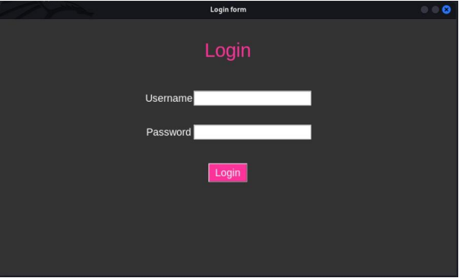

This interface is specifically for entering of marks manually, currently the GUI for that is not yet implemented. It’s the last step of our process as there are a lot of edge cases that are integral to the designing of GUI. Therefore, GUI will be designed in the final part of the project.

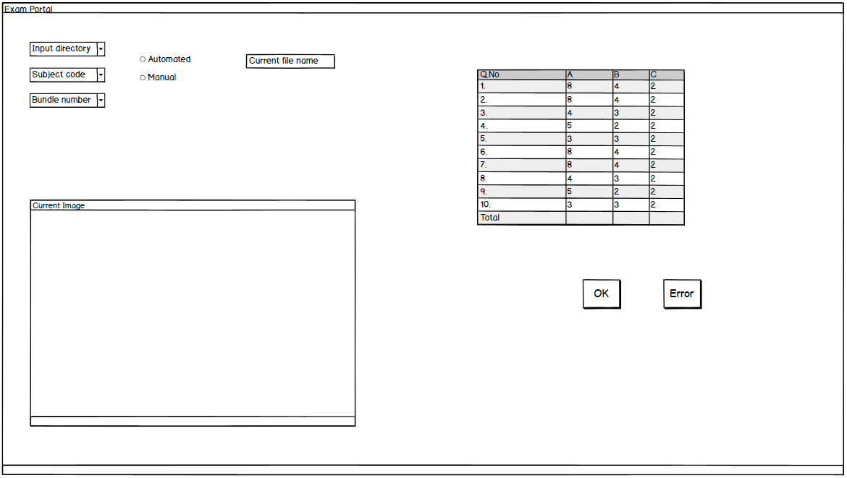

**2.2 Interface for viewing data:**

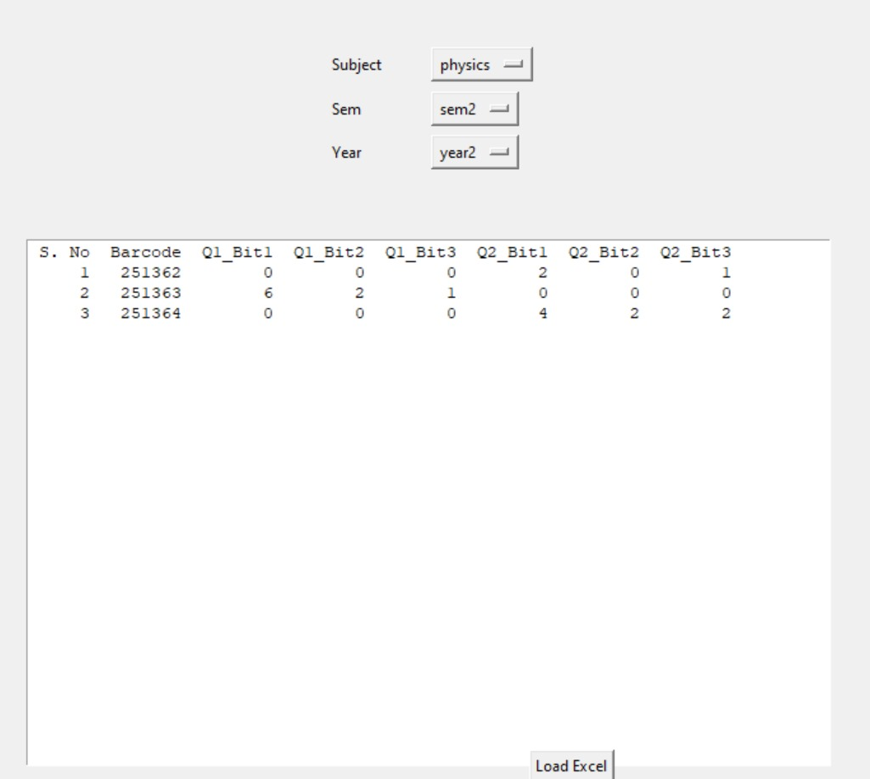

1. **IMPLEMENTATION**

**4.1 Crop whole marks sheet:**

Using cv2.rectangles, we measured which among the rectangles found from the marks sheet where the width > 55% of the whole width and height is > 33% of the total height. In the ideal case the whole rectangle is detected and sent to the next module.

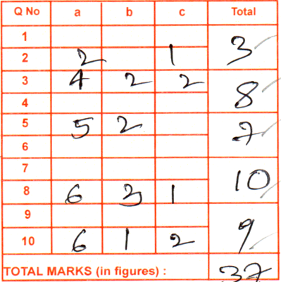

Done using <https://github.com/CH-Sampath/major_project/blob/main/crop_to_square.py>

**4.2 Induvial boxes retrieval:**



Using simple mathematics, we calculated the absolute positions of the junctions of each question and their respective bits.

Some absolute values are:

*cols = [0.00931, 0.182, 0.365, 0.556, 0.745]*

*rows = [0.01547, 0.093, 0.1725, 0.25, 0.331, 0.403, 0.48, 0.5633, 0.641, 0.7233, 0.8059, 0.9]*

Based on the indexes of the rows and columns, we can added the question and bit number along with the barcode into the filename for later modules. The file format is as follows:

*840009_250371.bmpresult_1_2*

Go to this for the full code: <https://github.com/CH-Sampath/major_project/blob/main/crop_final.py>

**4.3 Dataset creation using roboflow:**

Upload all the files into the roboflow architecture and manually label all of them as their digits. A bounding box is drawn that is used for yolov7. It saves the labels as follows:

*Class_id, centre_x, centre_y, width, height*

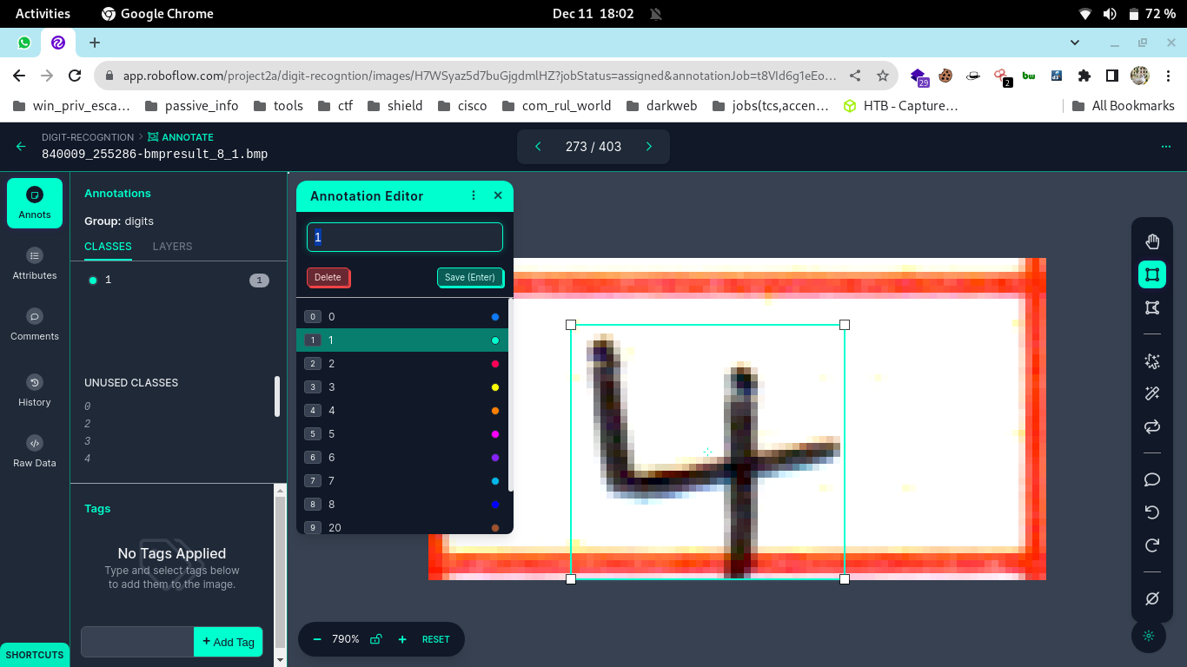

The dataset can be loaded into a computer as follows:

*from roboflow import Roboflow*

*rf = Roboflow(api_key="{insert api key}")*

*project = rf.workspace("project2a").project("digit-recogntion")*

*dataset = project.version(8).download("yolov7")*

<app.roboflow.com>

**4.4 Training yolov7 on the dataset:**

Trained a yolov7 model using google colab as it is resource intensive of approximately 4gb VRAM. The model was trained for *400 epochs* with a *batch size of 64* and the configuration file specifically for this model can be found here [in this yaml file](https://github.com/CH-Sampath/major_project/blob/main/yolov7-e6e.yaml).

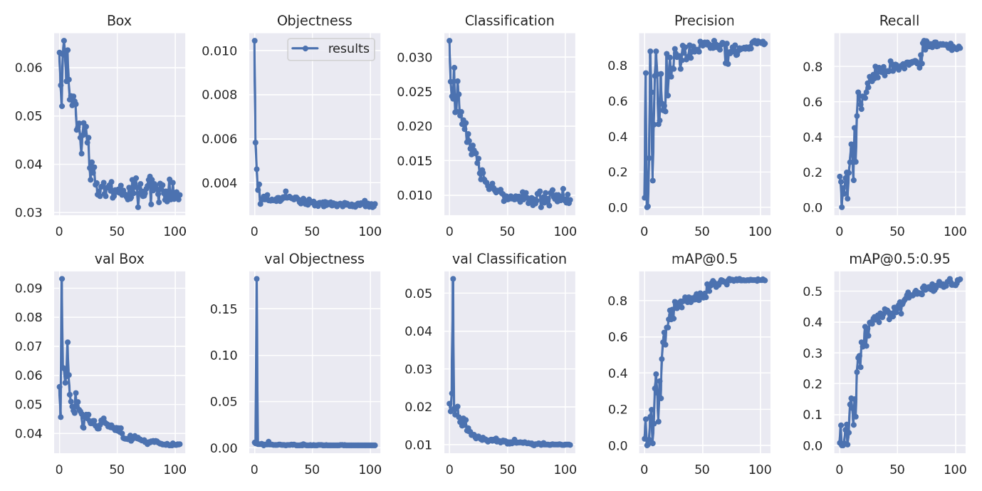

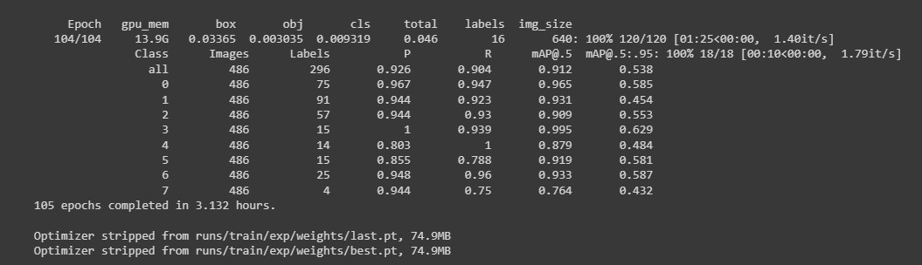

After training, the precision of each class is depicted in the above graphs and also in the above image, precision and recall of each class is printed at the end of the training

[train.py](https://github.com/WongKinYiu/yolov7/blob/main/train.py) in the yolov7 repository

**4.5 Detection of digits:**

Using the pytorch file, run the detection algorithm from the [detect.py](https://github.com/CH-Sampath/major_project/blob/main/detection.py) file. After running it the detected labels in a separate folder in text format that has the following format:

*Predicted-class-id centre-x, centre-y, width, height, confidence-level*

From that we can extract the numbers along with their question numbers and bits as mentioned in the above file format.

**4.6 Labels to excel:**

Having the barcode and other questions and bit numbers are extracted from the labels. Using pandas data frames create an excel with the subject name and enter the data into the excel.  
Immediately following the creation of excel sheets the data is encrypted and needs to be decrypted for usage.

**4.7 GUI to view analysis:**

Using a username and password a person logs into the system to view the excel or view analysis of the marks.

1. **TESTING**
2. **CONCLUSION & FUTURE WORK**
3. **REFERENCES**

|  |  |  |  |
| --- | --- | --- | --- |
| **Role** | **Faculty Name** | **Designation** | **Signature** |
| **Supervisor** |  |  |  |
| **Project Coordinator** | **Dr. P. Rama Santosh Naidu** | **Senior Assistant Professor** |  |
| **PRC Faculty-1** |  |  |  |
| **PRC Faculty-2** |  |  |  |
| **PRC Faculty-3** |  |  |  |
| **PRC Faculty-4** |  |  |  |

**Head of the Department**

**Computer Science and Engineering**

**MVGR College of Engineering(A)**

**Vizianagaram**